# **Return Workflow by Product Type**

* This document outlines the standard operating procedure for handling product returns.
* Products are categorized into three types:
* Odoo default product types

1. Consumable
2. Service
3. Storable product
   1. Fabric
   2. Blind
   3. Tracks

### **Consumable**

* + Consumable products in Odoo are items that are typically not tracked in inventory on a per-unit basis.
  + To return a consumable product:
    - Click **Return** from Delivery
    - In the return wizard, select the products being returned and specify the quantity.
    - Confirm the return and validate the return transfer.

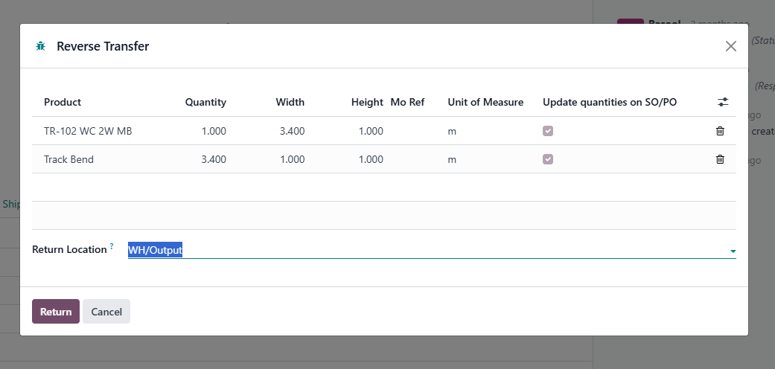

* + Once confirmed, a **return transfer** is created for both storable and consumable products.

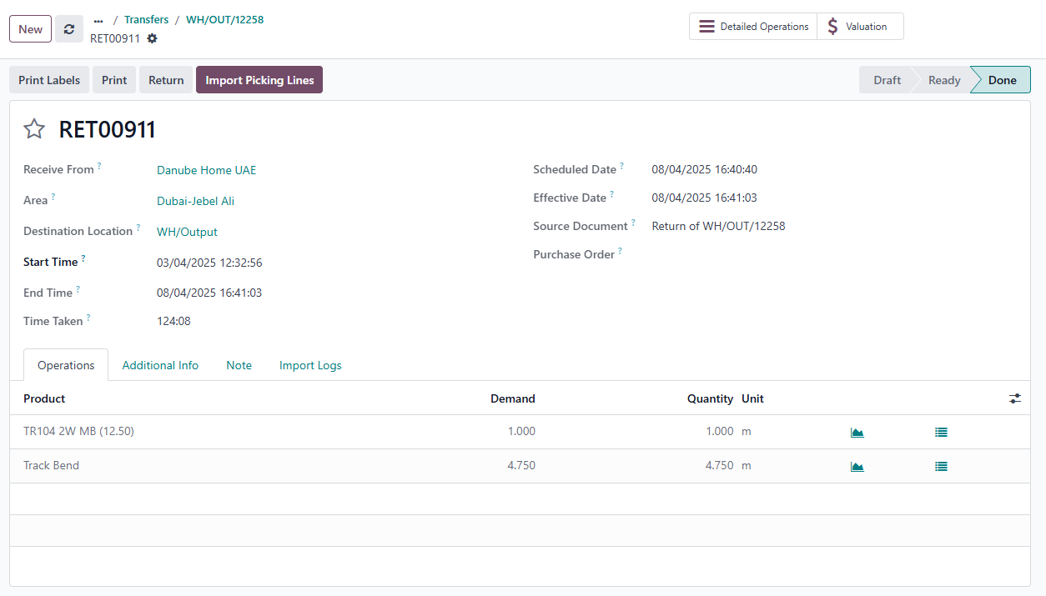

* + As a result:
    - A **credit note is automatically generated and posted**, just like with storable products.
    - A **return transfer** is created and recorded in stock move history.
    - Inventory valuation entries are created for both storable and consumable products.
  + However:
    - **No increase in on-hand quantity** occurs because consumables are assumed to be always available.
    - **No journal entry** is created for consumable products, even though the product is returned.

### 

* + For example,
    - **TR104 2W MB** (storable) is returned, and
    - **Track Bend** (consumable) is also returned —
    - TR104 2W MB is added back to stock with a journal entry, while Track Bend is not stock-adjusted and does not create an inventory journal entry.

### **Service**

* + Service products represent **non-physical items** such as installations, labor, or maintenance. Since these are **not stock-managed**, they do not participate in the delivery return workflow.
  + **No delivery or return is created** in Inventory for service products.
  + **No inventory movement** or valuation is recorded.
  + Service products are not automatically added to the credit note during the return process.

### **Storable product**

* + Storable products are inventory-managed items that are physically stored, tracked, and moved through warehouse operations.
  + To return a storable product, initiate a return from the validated delivery order. After selecting the product and quantity in the return wizard, Odoo generates a return transfer.
  + Upon validation:
    - A **credit note** is automatically created and posted, linked to the original invoice.
    - An **inventory valuation entry** is created.
    - The returned quantity is transferred from the customer location back to the warehouse.
    - The product is **added back to the on-hand stock**, and a **journal entry** is created and posted automatically for the inventory adjustment
  + **Types of storable products:**
    - Fabric
    - Tracks
    - Blinds
    - Blind Fabrics

#### **Fabric**

* + Fabric products are typically configured as **storable products with lot or serial number tracking.**
  + The return transfer is scanned and validated through the **Returns** operation in the Barcode app.
  + The lot number is scanned or manually entered.
  + The item is **added back to the on-hand stock**, and a **journal entry** is automatically posted for the inventory adjustment.
  + To return a fabric product:
    - Open the delivery that was already validated.
    - Click the **Return** button.
    - Select the fabric product and enter the quantity being returned.

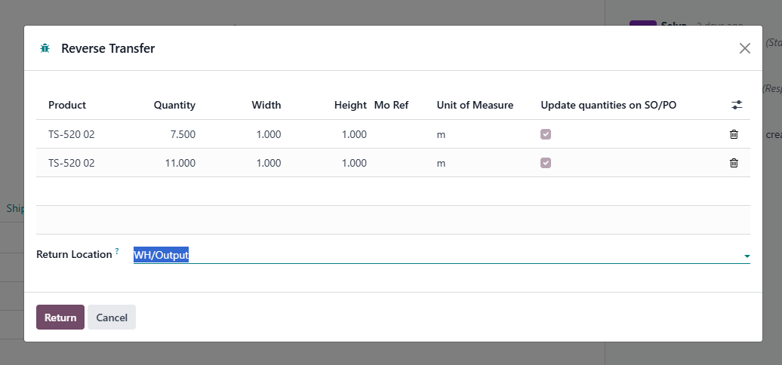

* + - Click **Confirm** — this creates a return transfer.

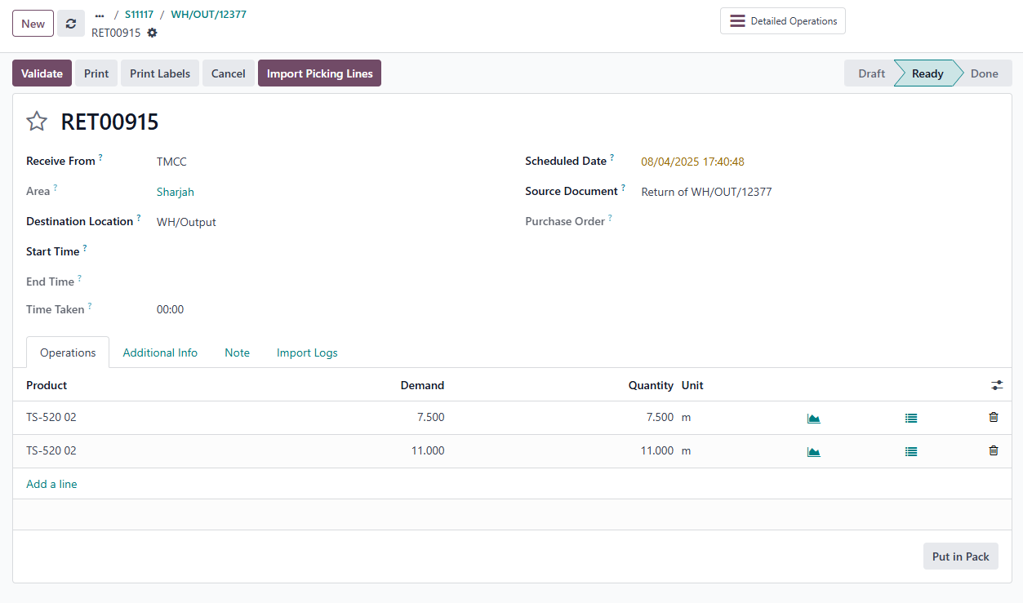

* + Instead of manually validating this return from here, process it through the **Barcode app’s "Returns" operation**.
  + Open the return operation of the barcode from this menu.

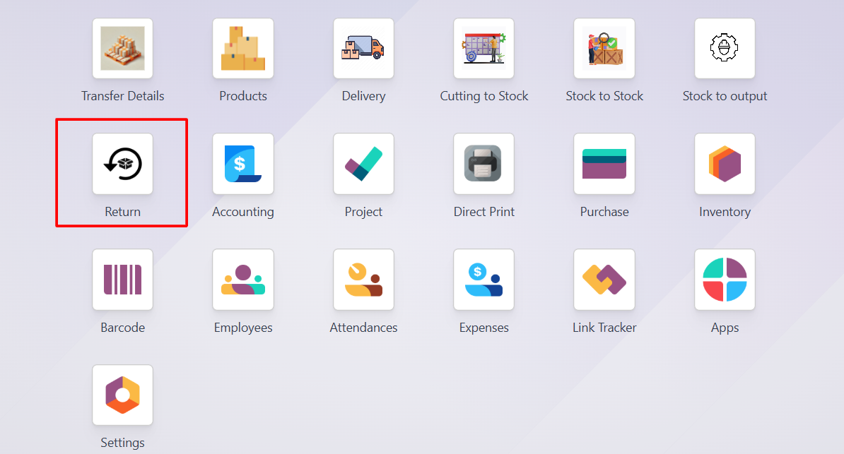

* + In that, you can see the return is created.

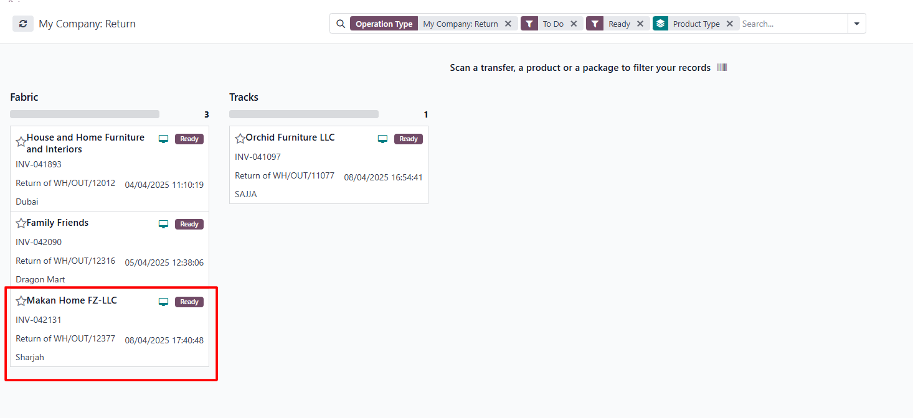

* + For fabric products, you need to add the lot number. And to add the lot number, go to the edit button.

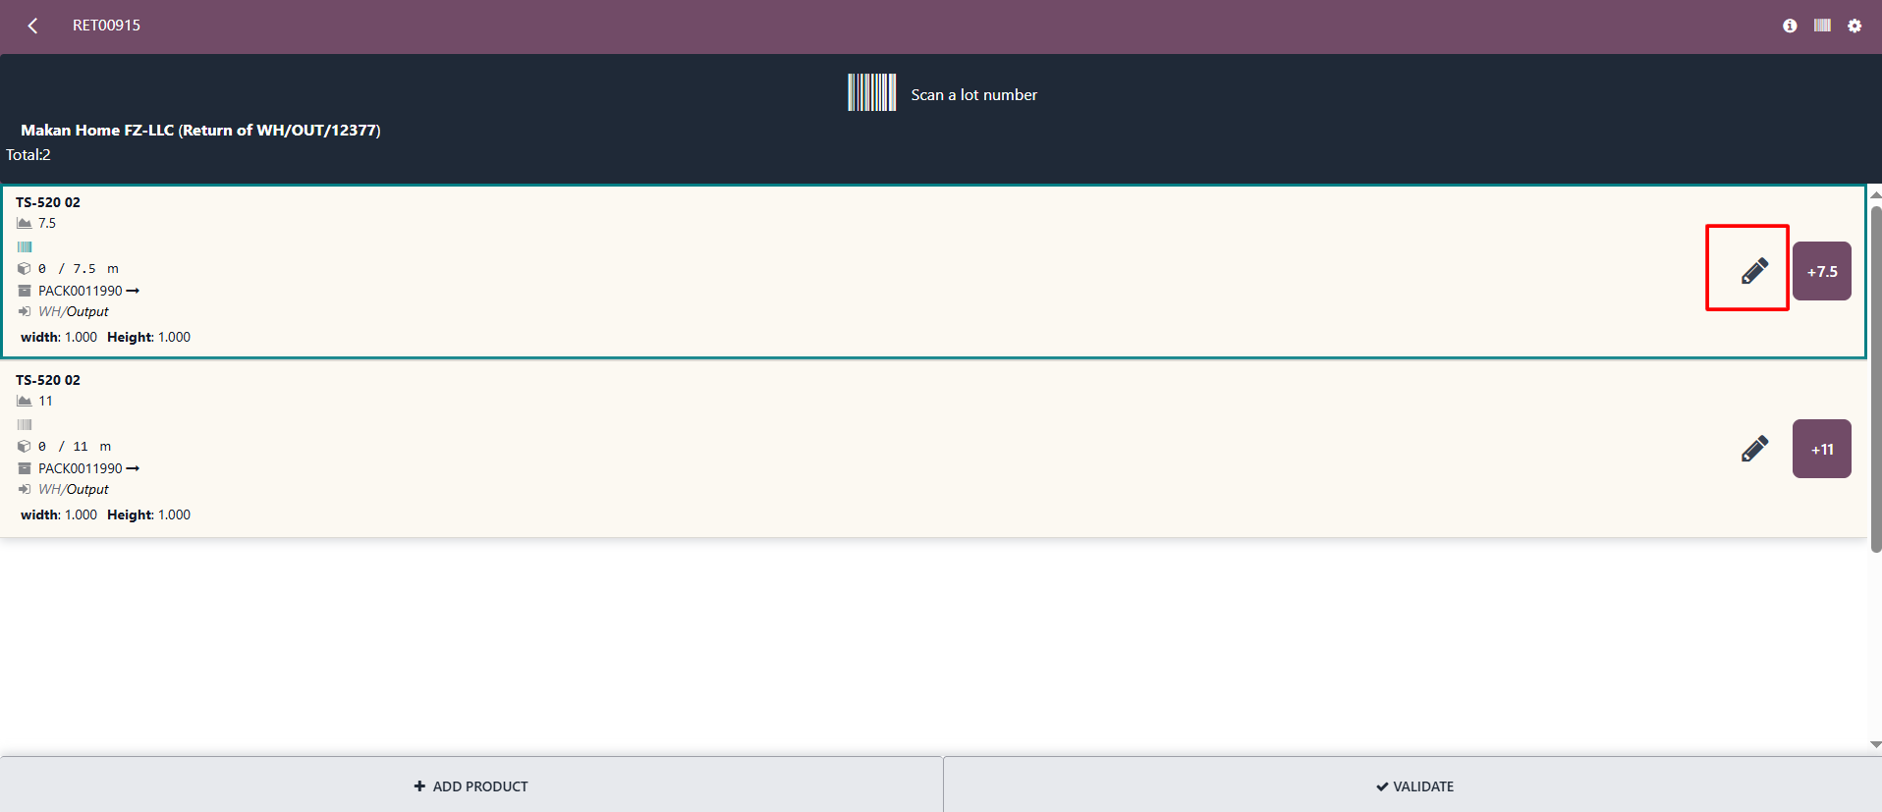

* + Add any number in the **Serial/Lot number as shown below.** The system will automatically generate a new lot number.

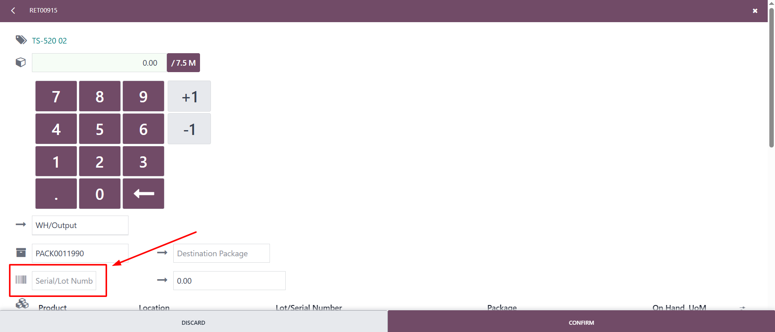

* + Then click the **Confirm** button.
  + Add a serial/lot number for all fabric products of return.
  + You can add quantity from the form view by using the edit button.

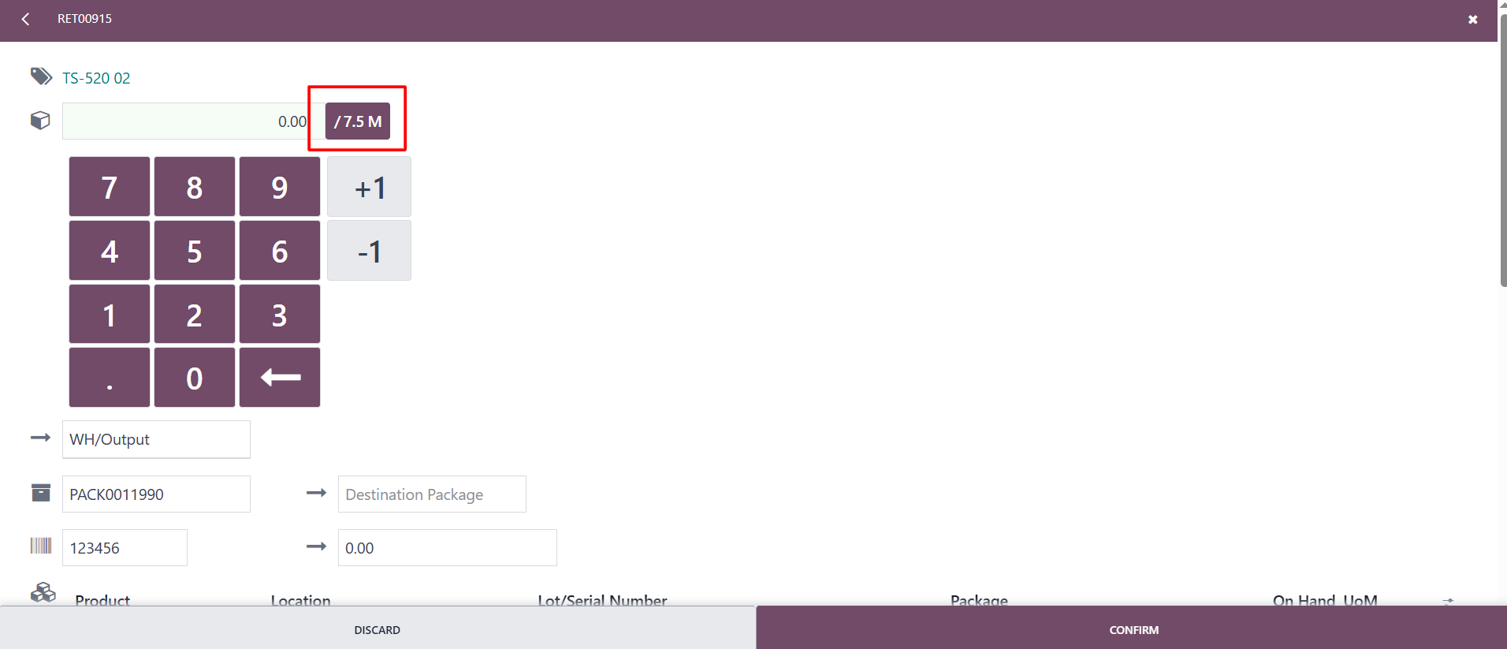

* + Or you can add quantity by clicking the quantity as shown below.

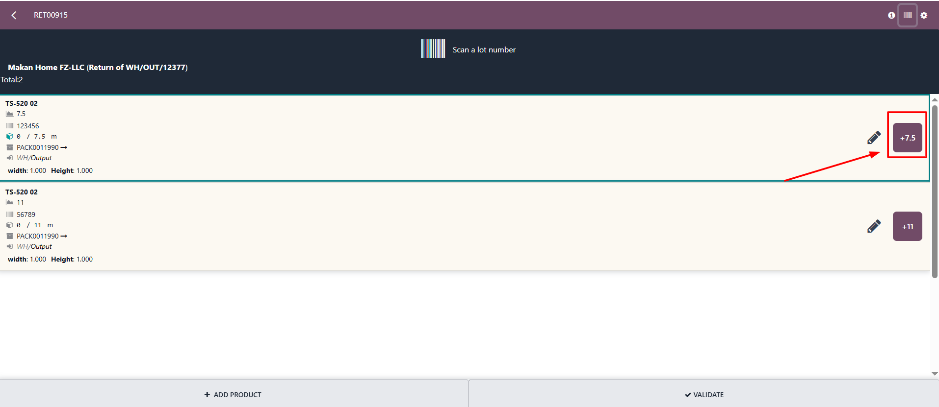

* + Once you add the lot number and quantities for all products, the validate button will become highlighted.

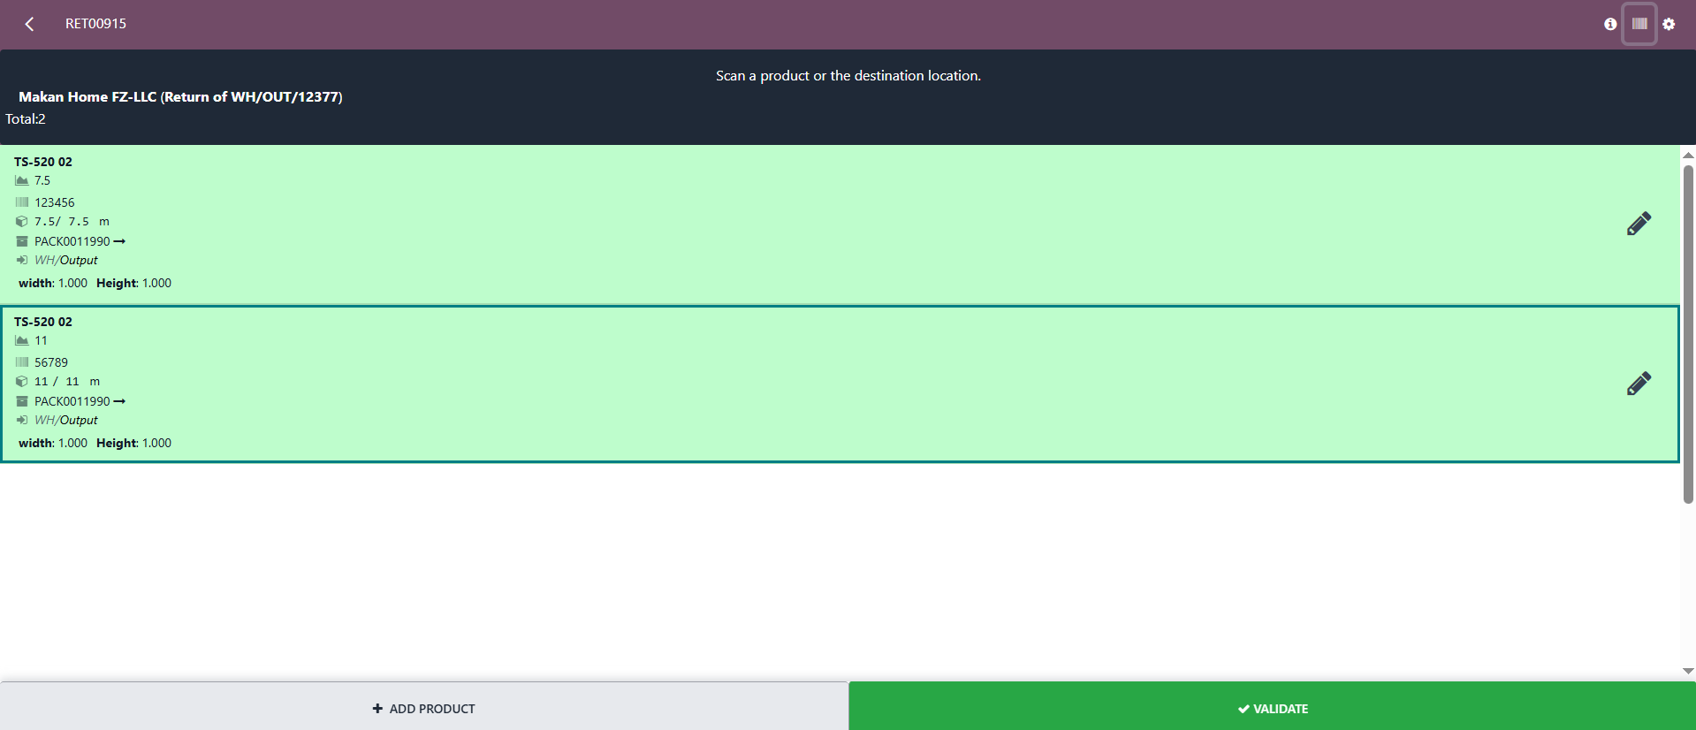

* + After clicking the Validate button, the return is validated and a reverse invoice (credit note) is created and posted automatically.

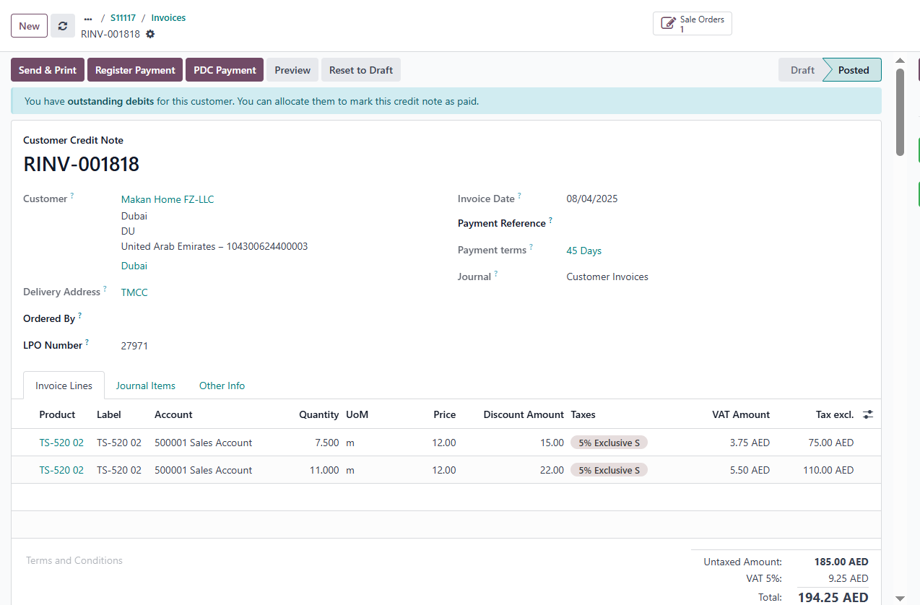

* + The returned quantity is moved from the customer location back to the **WH/output location**.
  + The returned quantity is **added back to on-hand stock**, and a **journal entry** is created and posted automatically for the inventory adjustment.

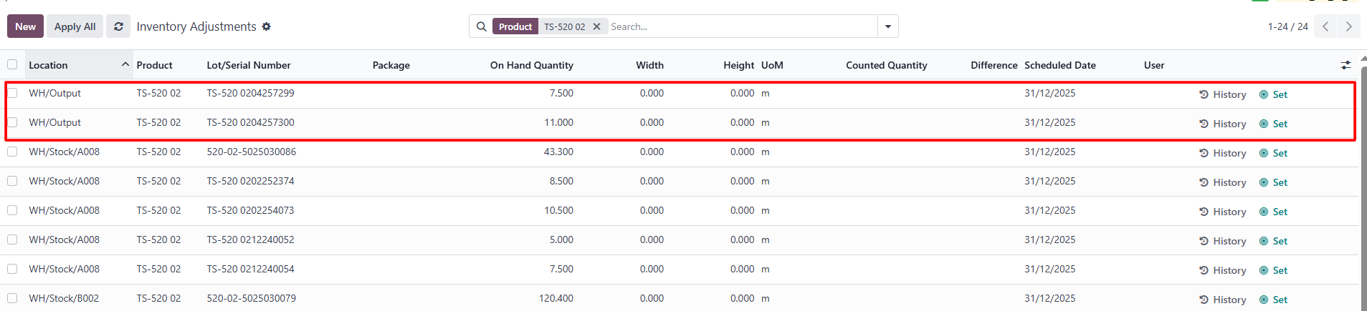

#### **Blinds**

* + Blinds are typically **manufactured, storable products,** and they are manufactured using **blind fabric** and other **BOM (bill of materials) components.** The return process should consider both the finished product and its components.
  + The return process for blinds is the same as for other storable products.
  + To return a fabric product:
    - Open the delivery that was already validated.
    - Click the **Return** button.
    - Select the blind products and enter the quantity being returned.

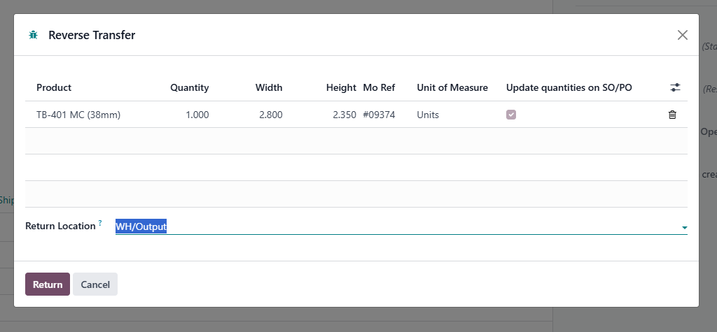

* + - Click **Confirm** — this creates a return transfer.

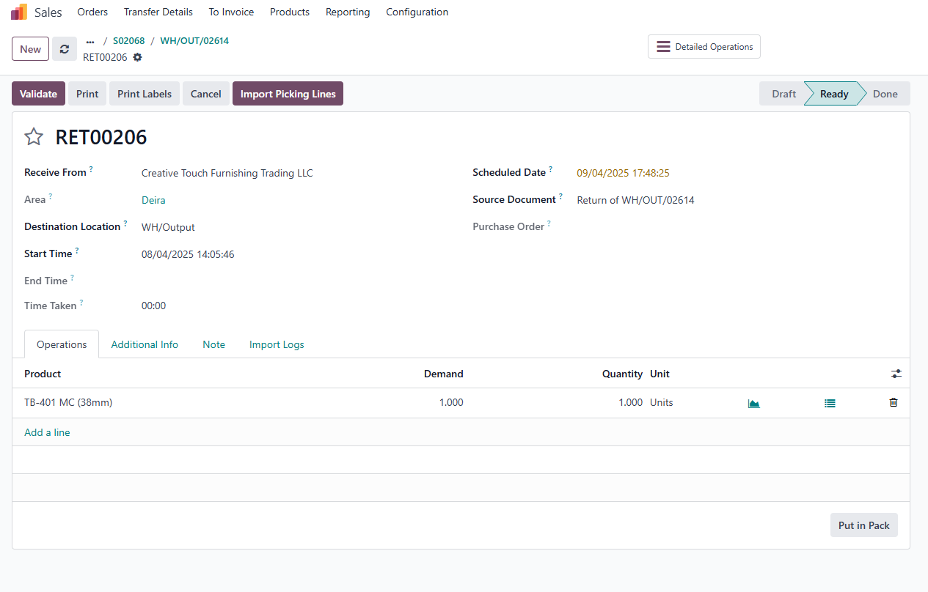

* + - Open the barcode **“Return”** menu.



* + - In that, the return is created.

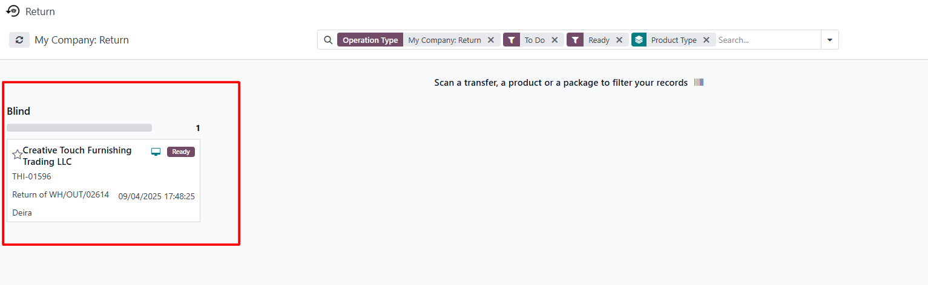

* + - Add the quantity as shown below and validate the return.

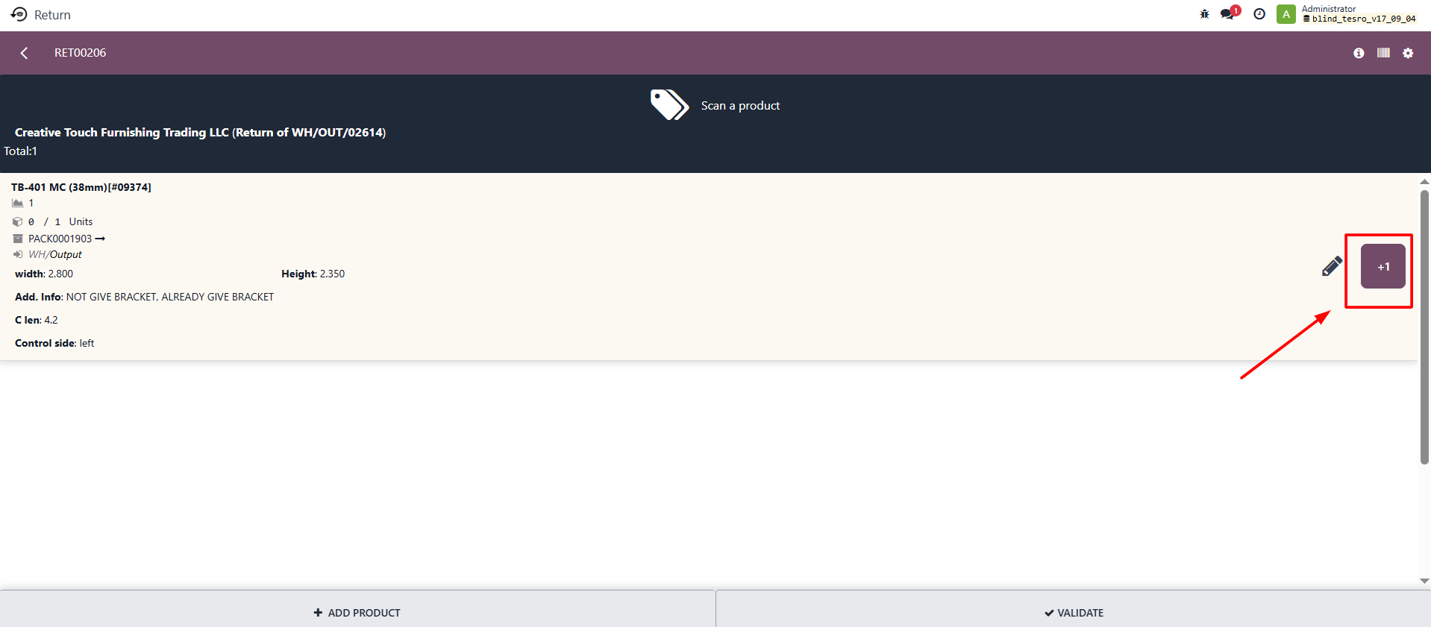

* + After clicking the Validate button, the return is validated, and a reverse invoice (credit note) is created and posted automatically for blind product.

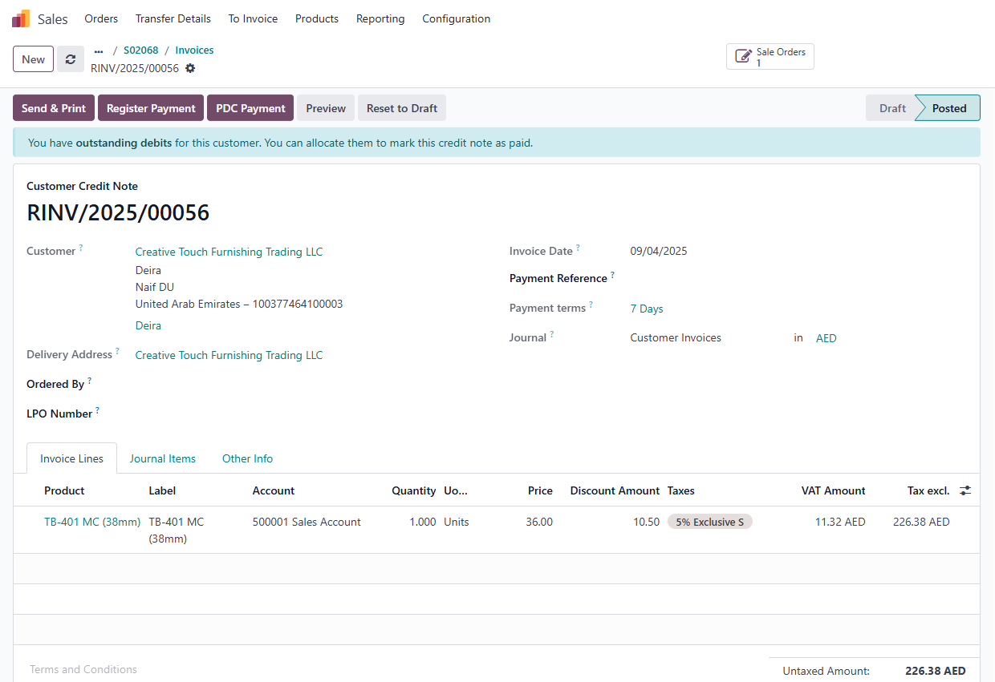

* + As a result:
    - The manufacturing order is also cancelled, and the component products are returned to the stock.

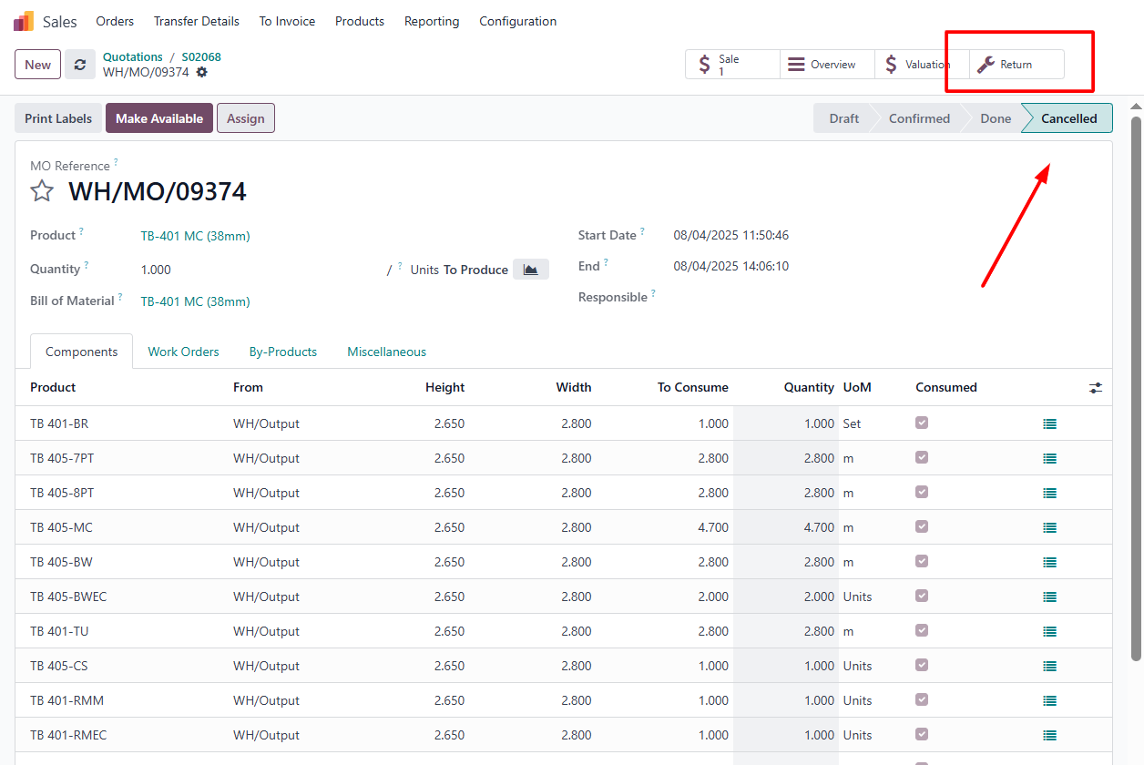

* + - The blind product is moved.
      * From **customer location → WH/Output → manufacturing location**.
    - The components are moved.
      * From **production → WH/Output** and added to on-hand stock.

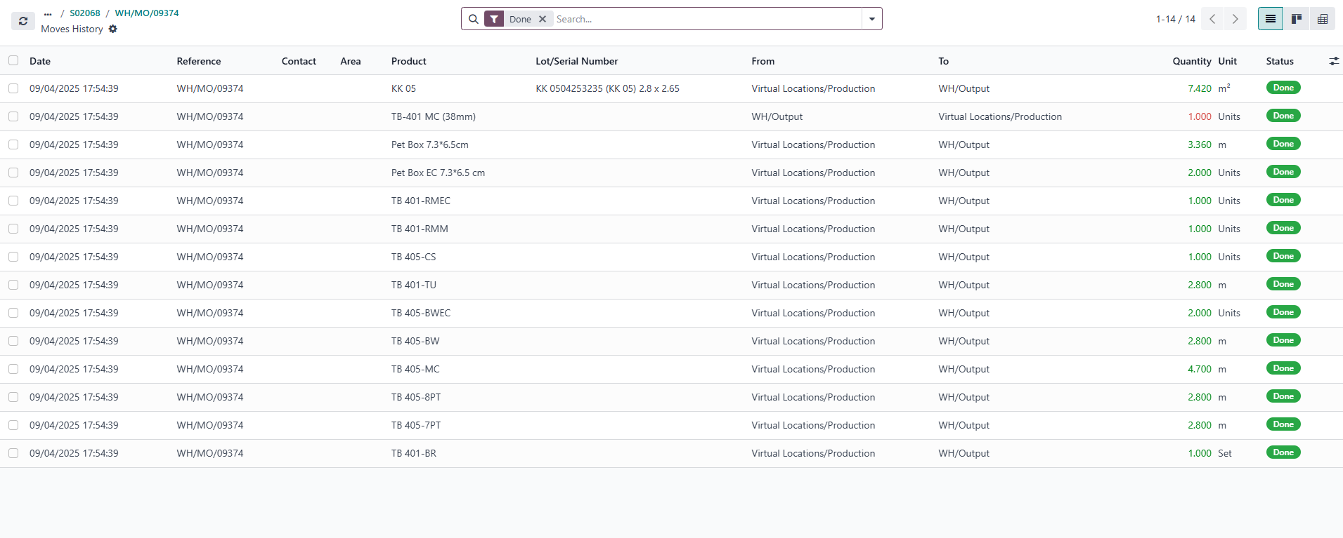

* + - The moves for blind, blind fabric, and components are created as shown below:

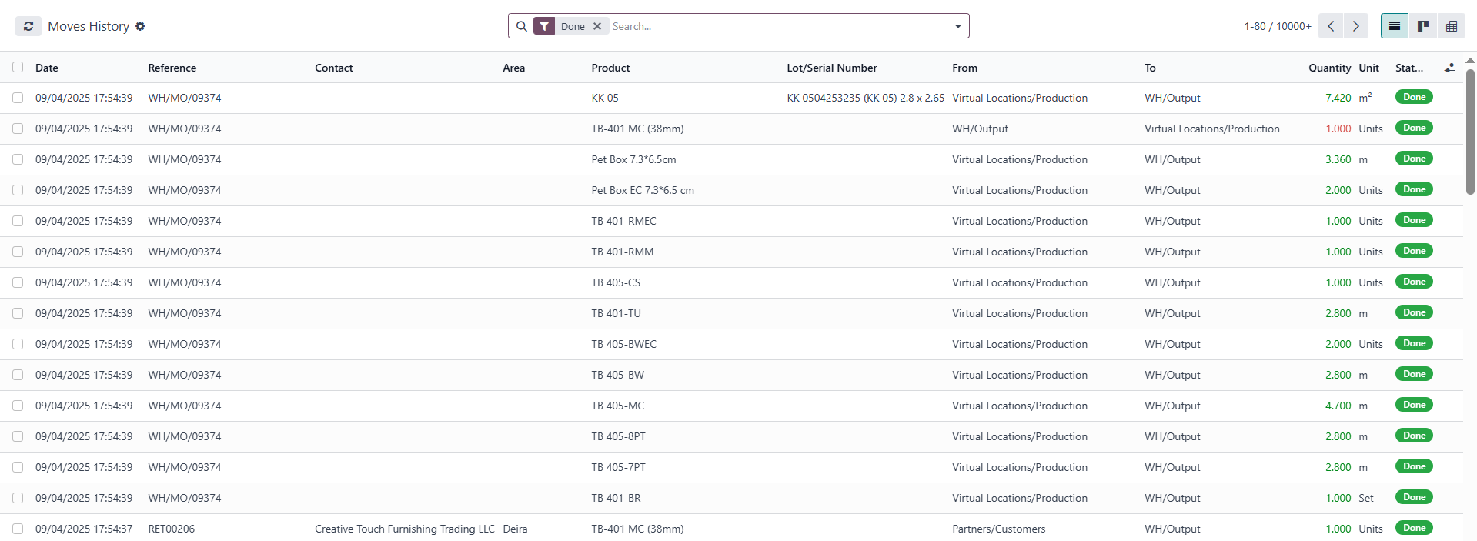

#### **Tracks**

* + **Tracks** are also treated as **storable manufactured products** in Odoo. Like blinds, they are created through a **manufacturing order (MO)**, but they **do not include fabric**.
  + Follow the same return steps as for blinds.
  + Create the same return as other storable products and validate it from the barcode “Return” menu.

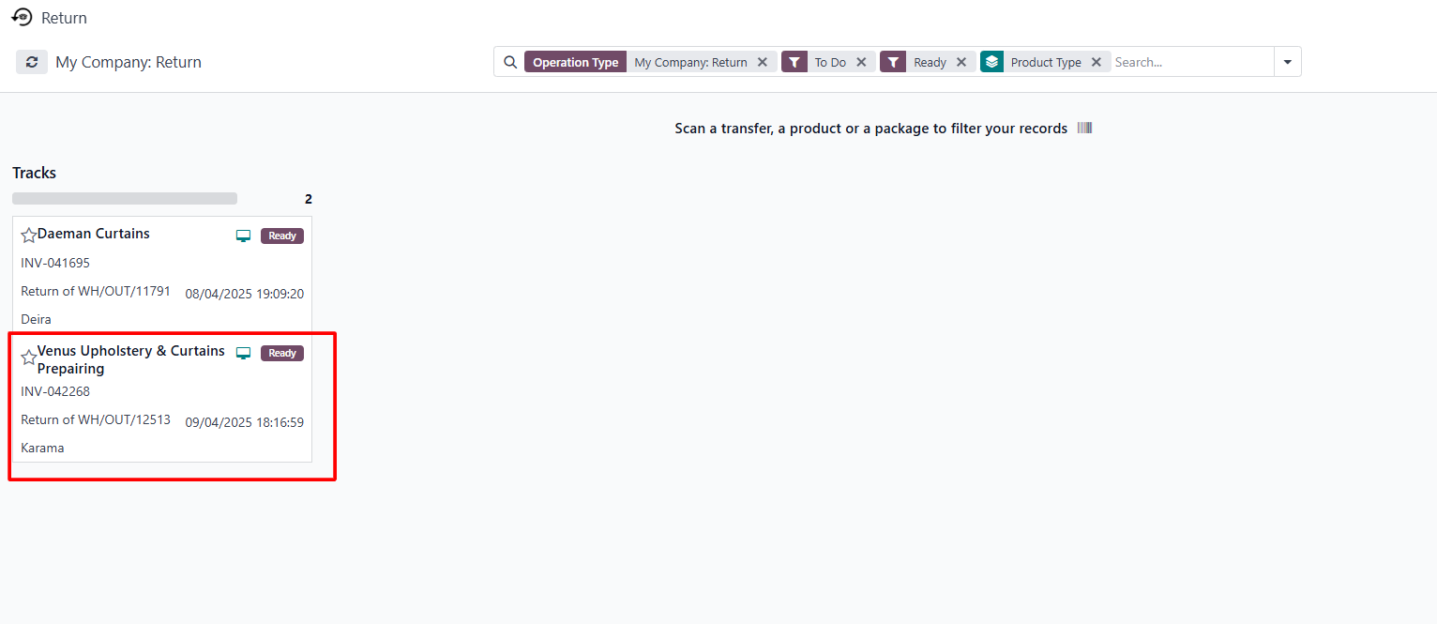

* + Add the quantities and validate the return.

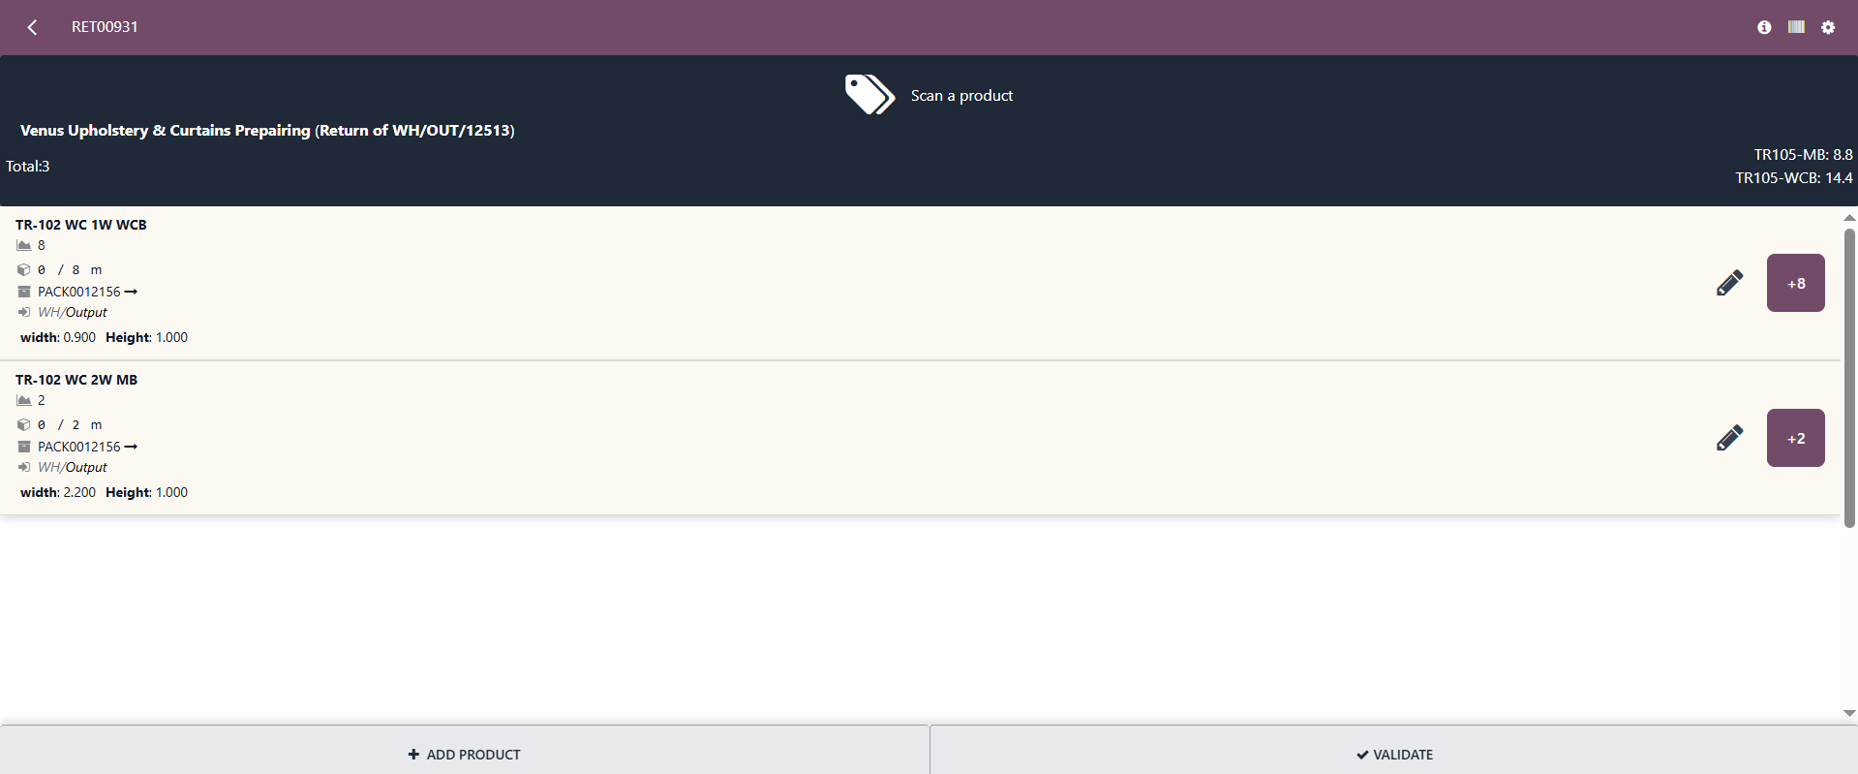

* + A **credit note is automatically generated and posted,** and a **return transfer** is recorded in stock move history.
  + The manufacturing order is also cancelled, and the component products are returned to the stock.

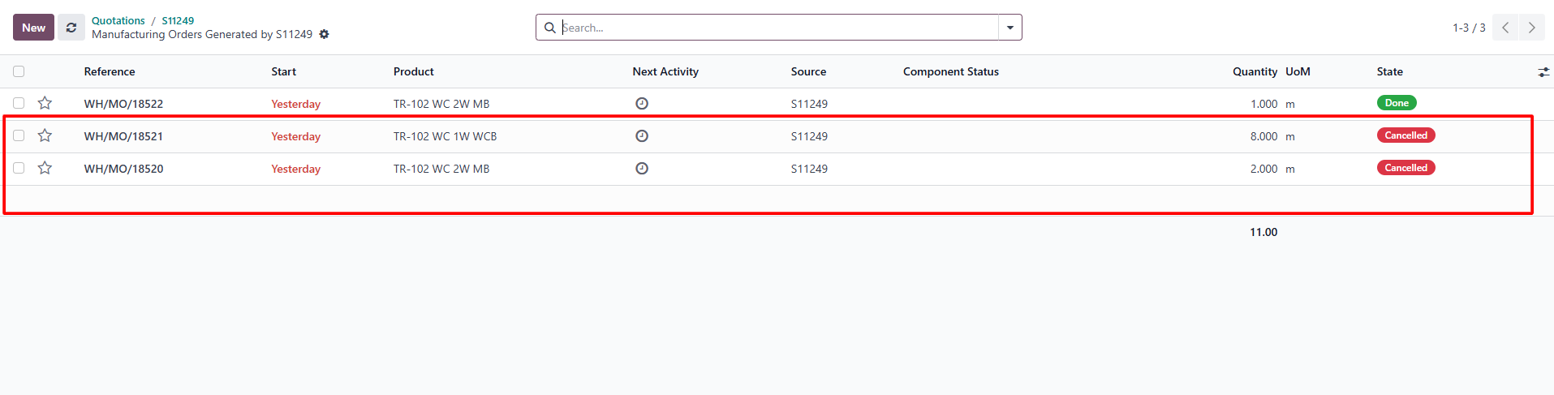

* + As we returned only two products from the delivery, only those product manufacturing orders are cancelled.
  + The **tracks** product is moved from the customer location back to the WH/Output location and then moved to the manufacturing production location.
  + The component products also moved from the production to WH/Output and added to an on-hand stock.

### **The return wizard allows users to select specific products and quantities for return, enabling both full and partial returns from the same delivery.**

#### **Full Return**

* + A **full return** is when the entire quantity of the delivered product(s) is returned.
  + The return transfer reflects the complete quantity originally delivered.
  + A **credit note** is automatically generated for the full invoiced value.
  + For storable products, full stock adjustments are made, and accounting entries are posted.

#### **Partial Return**

* + A **partial return** is when only part of the delivered quantity is returned.
  + A **partial credit note** is created based on the returned quantity and value.
  + Stock levels and valuation entries are adjusted accordingly.